Chardonnay
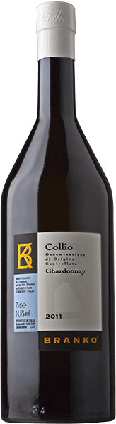
Igor brings out the best in his Chardonnay by fermenting and maturing about 30% of the wine in mid-sized oak containers. The wood imbues the wine with a complex swath of aromatics that fold into varietal fragrances of bananas and pineapples. Bottle ageing brings satisfyingly cushiony softness and robust structure. This is a wine with serious character, capable of significant sensory development in the second and third years after harvest.

