Bellone Bianco Wine
Bellone Bianco is a light-skinned white wine grape variety from Lazio, Italy. It is grown mostly in the vineyards around the Italian capital Rome (where it has been cultivated since antiquity), and plays an important part in the light, delicate white wines of the Roma DOC. In fact, it is so significant to the region's viniculture that Roma Bellone is one of only two varietal wine styles covered by the DOC title. Single-variety Bellone Bianco wines are also made in Marino (in the Castelli Romani just south of Rome) and from the coastal vineyards around Nettuno.
Although most often made into light, fresh-styled white wines such as those mentioned above, the variety is sometimes used to produce sweet, late-harvest wines. Its Arciprete ("archpriest") clone has proved particularly well suited to this application. Bellone Bianco grapes were once a key component in sweet Frascati Cannellino, although this is now typically produced from Malvasia and Trebbiano (the classic Vin Santo recipe).
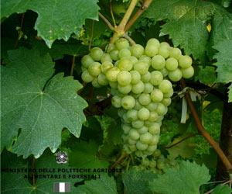
Bellone Bianco Grapes
© MIPAAF
Bellone Bianco vines are highly vigorous, and produce large bunches of medium-sized, late-ripening berries.
Bellone Bianco has a lesser-known, dark-skinned cousin, Bellone Nero.
Synonyms include: Arciprete Bianco, Cacchione, Pampanaro, Bellobuono.
Food matches for Bellone Bianco include:
- Lamb cooked in white wine with mint sauce
- Chicken tagine
- Pasta with lemon and broccoli

