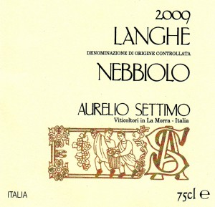
Langhe DOC Nebbiolo
Tasting notes
Langhe Nebbiolo is produced from grapes grown on the younger vineyards facing South-East, in the same area as the Nebbiolo used to make Barolo. The maximum yield of 8,000 kg./Ha is also the same.
Compared to the Barolo of the same vintage, the Langhe Nebbiolo undergoes a shorter maceration on the skins, and is not matured in wood. Its attractive tannins are therefore those found naturally in the Nebbiolo grape itself, and the wine has good structure.
It is normally ready to drink without needing to be aged.
In 2009 (outstanding vintage) our garnet red Langhe DOC Nebbiolo has an intense nose of ripe fruit, violet and wild berries.
A moderately tanniny flavour is highlighted on the mouth, blending nicely into the wine’s structure.
Basic informations
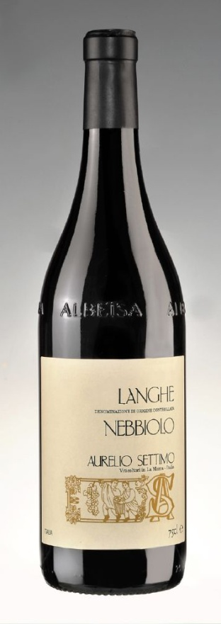
Product Name: Langhe DOC Nebbiolo
Cépage: Nebbiolo
Appellation: Langhe
Classificaton: DOC
Colour: Red
Type: Still
Country/Region: Italy, Piedmont
Vintage: 2009
Alcohol percentage: 14%
Sugar rate: < 0.3 g/l
Ageing: 48 months in concrete tanks
Number of bottles produced: 6,899
Vinification (Wine-making)
Method: according to tradition: short fermentations on the skins (submerged cap for 8-10 days), with frequent breaking up of the cap and pumping over of the must.
Temperature: 28 °C natural, not conditioned
Lenght: 8-10 days
Malolactic: done in concrete
Ageing: tradizional, 48 months in concrete tanks
Minimum ageing in bottle: 3 months
Bottle
Empty Bottle Weight: 530 gr
Date of Bottling: 13/02/2014
Ageing Potential: 6-8 years
Cork Size: 26 x 44
Cork Material: natural cork
Bottle Type: albeisa
Vineyard
% of Grape / Cépage: Nebbiolo (Lampia) 100%
Soil: calcareous
Exposure: South-East
Agricultural method: EC regulation 2078
Date of Harvest: 24/09/2009
Type of Harvest: by hand, with a careful selection of bunches
Chemical Analysis
Dry Extract [g/l]: 26.6
Total Acidity [g/l of tartaric acid equivalent ]: 5.75
Volatile Acidity [g/l acetic acid equivalent]: 0.48
Total SO2 [mg/l]: 67
Packaging:
Number of bottles per box: 12 or 6
Box size (cm): 34x27x31 or 31x26x17,4

